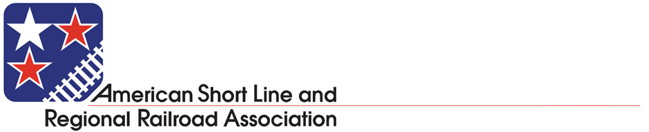

50 F Street, NW

Suite 500

Washington, DC 20001

aslrra@aslrra.org

www.aslrra.org

Contact:

Amy Krouse

akrouse@aslrra.org

(Cell) 312-371-6947

(Direct) 202-585-3438

**ASLRRA Comments on House Passage of the INVEST in America Act**

*Opportunity Remains Going Forward to Produce a Rail Title of Surface Transportation Reauthorization Bill that Benefits Short Line Freight Railroads and Supports the Key Role Short Lines Can Play in Growing the Economy, Protecting the Environment, Improving Transportation Safety, and* *Reducing the Congestion and Maintenance Burden of Heavy Freight on Highways*

**WASHINGTON – July 1, 2021** – In response to the House passage of H.R. 3684, the “Investing in a New Vision for the Environment and Surface Transportation (INVEST) in America Act,” the American Short Line and Regional Railroad Association (ASLRRA), which represents the nation’s 600 small business freight railroads and hundreds of railroad suppliers, offers the following statement:

“Short line freight railroads recognize and support the need for a large, sustained, transformational investment in our country’s infrastructure that will both enable America’s economic success and protect our environment far into the future,” said Chuck Baker, President, ASLRRA. “To that end, we congratulate Chairman DeFazio and his team for passing a surface transportation reauthorization in a vote of the full House.”

“For short line railroads specifically, work remains to ensure that any final legislation helps accomplish the worthy goals put forward – supporting long-term economic growth, improving transportation safety, and protecting the environment. For small business freight rail, there are a few beneficial provisions in this bill, such as a robust CRISI authorization level and significantly increased multimodal flexibility in the state freight formula program, but, as we have noted before, there are also a number of troubling provisions that will constrain short line growth, efficiency, and investment opportunities. These problematic provisions include new CRISI eligibilities and set-asides which will limit short line success in this crucial program, a crew size mandate that would negatively affect the efficiency of scores of short lines, a blocked crossing provision that would impede freight rail service, an unjustified ban on the safe movement of LNG by rail, the removal of small project eligibility in the INFRA/PNRS program, and improvements to the RRIF program that would not apply to short line applicants.”

“Now that this bill has passed through the House and two related bills have advanced through key Senate committees, there will soon be an opportunity to combine these bills – perhaps within the bipartisan infrastructure framework – to create a final legislative product that is beneficial for short lines and the thousands of communities we serve, particularly in small town and rural America.”

“We will continue to vigorously engage in this important process, working toward compromises on funding levels, robust support for short line freight rail infrastructure investments, and the removal of provisions that would unduly hinder short line progress. Legislation is achievable that would help short lines continue to advance critical bipartisan priorities – fostering environmental sustainability, improving transportation safety, supporting economic development, enabling mobility, and reducing the congestion and maintenance burden of heavy freight on the nation’s highways – and we look forward to a final product that we would be able to enthusiastically support.”

###

**About ASLRRA** - The American Short Line and Regional Railroad Association (ASLRRA) is a non-profit trade association representing the interests of the nation’s 600 short line and regional railroads and railroad supply company members in legislative and regulatory matters. Short lines operate 47,500 miles of track in 49 states, or approximately 29% of the national railroad network, touching in origination or termination one out of every five cars moving on the national railroad system, serving customers who otherwise would be cut off from the national railroad network. [www.aslrra.org](http://www.aslrra.org)